
An Example of the RateMyClassroom tool
Effective teaching and learning behaviours were extrapolated to a series of 25 ‘possibility statements’, which can be used to measure Collaborative Classrooms using a five-point Likert Scale. The possibility statements are arranged into four categories: Furniture, Engagement, Technology and Pedagogy, and can generate a maximum of 125 points, aggregated to a percentage value to achieve an ‘efficacy rating’. For example, a classroom yielding 100 out of 125 points achieves an 80% efficacy rating. This means that the learning environment being evaluated has achieved 80% of the available criteria for effective teaching and learning.
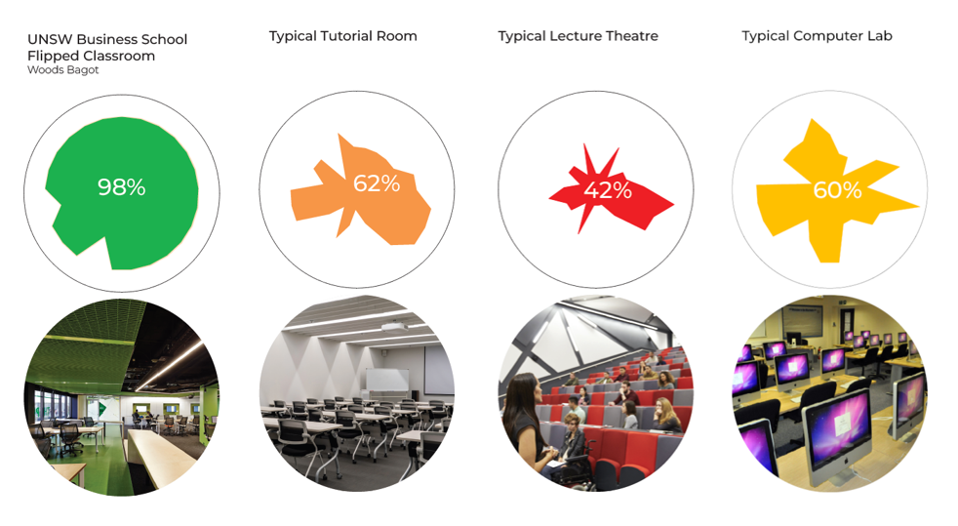
 | POSSIBILITY STATEMENTS | Typical Collaborative Classroom | Lecture Theatre | Tutorial Room | Computer Lab
Furniture
1. | It is possible for the teacher to move around the room easily and access all students equally and equitably. | 5 | 1 | 3 | 3
2. | It is possible for students and teachers to manipulate the physical environment to access appropriate resources and environmental conditions. | 5 | 1 | 3 | 2
3. | It is possible for students to conduct collaborative activities. | 5 | 3 | 3 | 2
4. | It is possible to easily move the tables and chairs around | 5 | 1 | 3 | 1
5. | It is possible for the teacher to meet individually and/or privately with students to provide direct feedback. | 5 | 2 | 3 | 3
Engagement
6. | It is possible for the teacher to engage with students individually. | 5 | 2 | 4 | 4
7. | It is possible for the teacher to engage with small groups of students. | 5 | 3 | 4 | 2
8. | It is possible for the teacher to engage with the whole cohort. | 5 | 5 | 5 | 5
9. | It is possible for students to interact at a ‘personal’ or ‘social’ distance as tasks are being established. | 5 | 4 | 5 | 3
10 | It is possible for students to move around to initiate full engagement of tasks at a ‘personal’ or ‘intimate’ distance. | 5 | 4 | 5 | 3
11. | It is possible for different students to undertake activities at different levels of engagement and at varying distances, simultaneously in the classroom. | 5 | 2 | 4 | 2
12. | It is possible for student groups to display the product of their interactions and discussion for the teacher and other students to see. | 4 | 1 | 2 | 2
Technology
13. | It is possible for the teacher and students to access the same educational technologies (such as digital screens) | 4 | 1 | 1 | 4
14. | It is possible for students to utilise learning resources including the available technologies, e.g. whiteboard, digital screen, document camera, internet, computer/tablet, etc | 4 | 1 | 2 | 4
15. | It is possible for students to capture content presented by the teacher and/or the product of interactions with other students. | 4 | 3 | 3 | 3
16. | It is possible for student groups to equitably access educational technologies | 4 | 1 | 1 | 2
17. | It is possible for students to access resources relevant to their needs. | 4 | 2 | 2 | 4
Pedagogy
18. | It is possible for students to work at their own pace during class. | 5 | 2 | 4 | 4
19. | It is possible for students to undertake focused tasks during class. | 4 | 3 | 4 | 4
20. | It is possible for students to engage in different activities at the same time. | 5 | 2 | 4 | 4
21. | It is possible for students to utilise vacant floor space for learning activities (active floor). | 5 | 1 | 2 | 1
22. | It is possible for the teacher to adapt their teaching approach in response to different student cohorts based upon their prior learning experiences. | 4 | 2 | 3 | 3
23. | It is possible for students to undertake learning activities that are relevant to them and their learning context. | 5 | 2 | 3 | 3
24. | It is possible for the teacher to visually scan the room to monitor students, evaluate progress and effectively identify students who may need assistance. | 5 | 1 | 1 | 3
25. | It is possible for students to present their work to the teacher and the entire class for feedback. | 5 | 3 | 4 | 4
 | Total points out of 125 | 117 | 53 | 78 | 75
 | Efficacy Rating (out of 100) | 94% | 42% | 62% | 60%

